

**Central bank psychology**

Speech given by Andrew G Haldane

Leadership: stress and hubris conference hosted by the Royal Society of Medicine, London 17 November 2014

The views are not necessarily those of the Bank of England or the Monetary Policy Committee. I would like in particular to thank Rashmi Harimohan, Jeremy Franklin, Michael McMahon and

Nick Mclaren for assistance in preparing the text. I would also like to thank John Barrdear, Rob Elder, Bob Gilhooly, Chris Hackworth, Jeremy Harrison and Gareth Ramsay for their comments and contributions.

13 September 2007 will be seen as a red letter day in financial history. It was the date news broke of Northern Rock seeking emergency liquidity from the Bank of England, prompting the first run on a UK bank in over a century. It also fired the starting gun on what subsequently became known as “The Great Recession”. That very day, the Bank hosted a conference. In a painful irony, its theme was “The Great Moderation”.

The Great Moderation described the long-period of pre-crisis macro-economic calm, with stable growth, stable inflation and stable banks.1 This view held that central banks, while not eliminating boom and bust, had moderated macro-economic undulations. It also held that financial innovation, while not eliminating risk, had scattered it to the four winds.

As Great Recession abruptly replaced Great Moderation, it was clear a grave analytical and policy error had been made. Economic and financial pride had come before a momentous fall. Nemesis had duly followed hubris.2 It was the coldest of comforts that this cognitive lapse was shared by the whole economic and policy-making profession.

Clinical diagnoses of this failure will continue for some time. Was this an example of the intoxicating effect of power, the anaesthetising effect of success, or the humbling effect of uncertainty? I do not know. But if nothing else, this episode underlines the importance of cognitive constraints on decision-making when assessing the robustness of policy.

Over recent years, there has been a huge amount of research on how human decision-making is affected by various cognitive biases.3 Behavioural economics, the fusion of psychology and economics, has come of age. There has also been a huge amount of research over many years on central bank decision-making.4 Yet the link between the two – the psychology of central banking – has to date been largely unexplored territory.5

I want to engage in a little amateur psychology by beginning to explore that terrain. Psychology tells us that behavioural biases, because they are neurologically hard-wired, are often difficult to detect: they are unconscious biases. Simply recognising the cognitive constraints on decision-making is thus a first step towards making policy robust to them.

So too is institutional design. Indeed, I wish to argue that the evolution of central bank policy frameworks over recent years can be seen as an attempt to make them robust to psychological biases. I want to illustrate that by

1 It was a term first popularised by Ben Bernanke, then-Chairman of the US Federal Reserve Board (Bernanke (2004)).

2 In Greek mythology, Nemesis was the spirit of divine retribution against those who succumb to hubris (arrogance before the Gods). The term hubris now typically refers to a loss of contact with reality and an overestimation of one's own competence, accomplishments or

capabilities.

3 Loewenstein *et al* (2008), Kahneman (2011), Mischel (2014), Urminsky and Zauberman (2014).

4 Blinder (2004), Reis (2013) and Friedman and Schwartz (1963).

5 There are some obvious exceptions in research on monetary policy decision-making, discussed below. Sibert (2006) also discusses the topic of “Central bank psychology”.

reference to the Bank of England’s policy framework. And, based on that analysis, I want to suggest some areas where a further evolutionary “nudge” in those frameworks might be warranted.6

# Behavioural biases in practice

The literature on behavioural economics has sky-rocketed over recent years.7 This identifies a long list of cognitive ticks that can affect human decision-making. All of these are likely to affect policy decision-making to some degree. But from that potentially very long list, let me highlight four biases which may pose a particular policy-making challenge.

*Preference biases*

Public policy involves making choices on society’s behalf. Society typically delegates these choices to an individual or set of individuals, often either politicians or bureaucrats. That act of delegated authority means that policy decisions usually involve both a principal (society) and an agent (such as government). The nature of that principal/agent relationship then becomes crucial for effective policy.8

Yet history suggests that this relationship is not always entirely harmonious. One potential source of friction is that the agent may have preferences which are not perfectly aligned with society at large. This is human nature. For example, it might arise from the agent putting personal objectives over societal ones, such as personal power or wealth.9

These problems have been widely studied in political and management science. In their extreme form, this preference misalignment can manifest itself as autocracy (the pursuit of personal power at society’s expense) or corruption (the pursuit of personal wealth at society’s expense). Historically, such “extractive regimes” have had dire consequences for societal welfare. Indeed, they may explain “Why Nations Fail”.10

Historically at least, the antidote to these preference problems is typically found in institutions – property rights, the rule of law, democratic processes. Strong institutions have often laid the foundation on which nations have been built. Typically, these institutional structures comprise an ex-ante mandate (agreed by society) and

ex-post accountability mechanisms (assessed by society). Colloquially, these are often called checks and balances.

For example, electoral democracy is an institutional response to a potential preference misalignment between the electorate and the polity. Parties publish manifestos ex-ante to set their mandate. And, if successful, they

6 A term first popularised in the Book ‘Nudge: Improving Decisions about Health, Wealth, and Happiness’ (Thaler and Sunstein (2008).

7 As discussed in Diamond and Vartiainen (2007).

8 Bergman and Lane (1990).

9 Gailmard (2014).

10 Acemoglu and Robinson (2012).

are held accountable for that mandate by society ex-post through elections.11 Democracy, and its associated institutions, is the solution to an ageless principal/agent problem.

What is true at the level of the nation state is also true at the level of the firm and the individual. In firms, principal-agent problems can arise because managers put their own preferences (for mega-mergers, mega-bonuses, mega-jets) ahead of shareholders.12 They also arise from workers putting their own preferences (say, for an easy life) over managers.13 Institutional structures – in this case, company and employment law – can help solve these problems.

Among individuals, preference biases can also have negative societal implications. In the medical profession, there is research arguing that doctors systematically over-prescribe drugs and over-admit patients to hospital.14 Neither may be in the patients’, nor societies’, best interests. This is usually the result of doctors weighing their own preferences (the risk of reputational or financial loss) over the patient’s (the risk of health problems worsening).

*Myopia biases*

Psychological experiments show that people differ materially in their capacity to defer gratification. The classic example is the “Marshmallow test” devised by Walter Mischel in the 1960s.15 Mischel gave children at Stanford University’s Bing Nursery School the choice between one marshmallow for immediate consumption or two if the child waited.

Not only did children differ significantly in their ability to defer gratification. As researchers followed the fortunes of these children as they grew older, a remarkable pattern emerged: children which had exhibited greater patience in their pre-school marshmallow test subsequently outperformed their impatient counterparts in everything from school examinations, to salaries, to reported levels of life satisfaction.

Subsequent sociological studies have established a longer list of ways in which impatient or myopic behaviour influences human decision-making. Myopic individuals are more likely to smoke, to suffer alcohol and drug addiction problems, to be obese and to have credit card debt problems.16 Myopia also differs significantly across countries.17

To explain this, Richard Thaler developed a psychological model based on the “two selves”. In effect, each of us comprises a patient “planner” and an impatient “doer”.18 Neuro-scientific evidence has subsequently lent

11 Frerejohn (1986).

12 Jensen and Meckling (1976).

13 Ross (1973).

14 Orlowski and Wateska (1992).

15 Mischel (2014).

16 As discussed in Urminsky and Zauberman (2014).

17 Wang *et al* (2011).

18 Thaler and Shefrin (1981).

support to Thaler’s model, with different areas of the brain found to be responsible for patient and impatient behaviours.19

In practice, myopic behaviour appears often to hold sway in everyday decision-making. People appear consistently to discount too heavily future rewards, a property called hyperbolic discounting.20 This can explain myopic saving behaviour by households and companies, when tomorrow’s consumption is brought forward to today.21 And it can explain political business cycles, when tomorrow’s GDP is brought forward to today.22

Myopic behaviour also appears rife in risk decisions. People appear to exhibit risk myopia, discounting risk events more heavily the longer the period that passes without that risk materialising.23 This is the behaviour we see from car drivers whose speed gradually increases after witnessing an accident. It was also the behaviour we saw during the Great Moderation when financial markets suffered progressively greater risk myopia

(Chart 1).

*Hubris biases*

In 1965, psychologist Stuart Oskamp performed a multiple choice test on a group of psychology students based on a case study. He also asked them to assign a confidence rating to their answer. 24 The students were then given more information on the case study and asked to answer further questions with a confidence rating.

He found that additional information did nothing to improve the accuracy of the students’ answers. It did, however, cause the confidence rating they attached to these answers to rise significantly. The addition of information and experience led students to become over-precise, to over-estimate their abilities, to over-state their performance.

There is no shortage of casual evidence of such hubris or over-confidence biases. 90% of faculty at the University of Nebraska rate themselves as above-average teachers.25 Over 90% of US students rate themselves as above-average drivers.26 And over 80% of Frenchmen rate themselves to be above-average lovers.27

Over-confidence biases have been widely studied in politics and management. There is a degree of Darwinian self-selection at work here. Over-confident individuals tend to outperform in tournaments.

19 McClure *et al* (2004), Figner *et al* (2010) and Lowenstein *et al* (2008)

20 Ainslie (1975).

21 Laibson (1997).

22 Nordhaus (1975).

23 Kahneman and Tversky (1979) and Thaler, Kahneman, Tversky and Schwartz (1997).

24 Oskamp (1965).

25 Cross (1997)

26 Svenson (1981)

27 Taleb (2007)

This means they are more likely to occupy positions of influence in the first place, whether Prime Minister or CEO, though not Chief Economist.28

But the same factor that pushes these individuals to the summit may also push them over the edge.

Over-confidence increases the risk of over-reach – for example, pursuing over-ambitious targets or undertaking over-complex company takeovers, generating an above-average risk of systemic failure. That is why nemesis is often thought to follow hubris.

What is true of those managing countries and companies appears to be no less true of those managing money. Investment managers have consistently been found to over-estimate their abilities and traders consistently to over-trade their positions. On average, there is little evidence of either consistently out-performing their peers.29

Over-confidence effects tend to be more acute among individuals than groups, as groups dilute the influence of hubristic individuals, as well as promoting a greater understanding of others’ perspectives. Consistent with that, studies of decision-making by the US Supreme Court in the US have found benefits from expert, unelected committees.30

*Groupthink biases*

In 1951, Solomon Asch conducted a series of tests on a group of students. Each was asked in turn to state which of three lines on a card matched the length of the line on a separate card.31 The twist came in the fact that all but one of the participants was an actor, primed to give the wrong answer. The real student, answering last, then responded.

These Asch experiments found something remarkable. The unsuspecting student conformed to the group’s wrong answers between a third and a half of the time. Their decision-making suffered a systematic conformity bias. Interestingly, if as little as one dissenting view was added, this conformity bias was reduced by up to 75%.

In 1972, Irving Janis called this tendency for groups to act cohesively “groupthink”.32 Janis focused on a number of US political decisions to motivate this concept, the most celebrated of which was

President Kennedy’s decision to invade the Bay of Pigs in 1961. More recently, groupthink was used to explain the Challenger space shuttle disaster.33

Groupthink is the collective manifestation of confirmation bias - the tendency to search and synthesize information in ways which confirm prior beliefs. This, rather than alcohol, is why drunks search for lost keys

28 Goel and Thakor (2008).

29 Kahneman (2011).

30 Iaryczower *et al* (2013).

31 Asch (1951).

32 Janis (1972, 1982).

33 Hughes and White (2010).

under the lamppost.34 Confirmation bias is prevalent in uncertain environments, where popular narratives are used to filter uncertainties.35

Psychologists such as Janis have identified a number of ways to mitigate groupthink or confirmation bias. Actively encouraging dissent in groups is one. Seeking alternative perspectives from outside experts is a second. And having the group chair state their preferences last is a third.36

# Evolution of Bank of England’s policy framework

Let me now describe the evolution of the UK’s macro-economic policy framework over the past half-century or so. This is a journey whose starting point was a rules-based regime over which the Bank had little discretion and whose finishing line is a regime over which the Bank exercises significant discretion.

For much of its 320-year history, the Bank of England’s role in UK economic policy was as operational agent. The role of policy principal was played by government. 37 In the setting of monetary policy, the Bank’s role from the end of the second world war through to the 1990s was as implementer, not decision-maker. The Bank had little, if any, independence in the setting of monetary targets or instruments.

That changed progressively in the 1990s and decisively after 1997. Through the *Bank of England Act 1998*, the Bank was granted operational independence for the setting of monetary policy in the UK, to meet an inflation target set by government. Specifically, monetary policy came to be set by a nine-person

Monetary Policy Committee (MPC), meeting monthly and comprising five Bank “internals” and four “externals”.38

In the light of the crisis, the UK’s policy framework has been further changed. The *Financial Services Act 2012* vested the Bank with further responsibilities, creating a new 10-person Financial Policy Committee (FPC), meeting quarterly to execute macro-prudential policy. The FPC sets regulatory policy to ensure the stability of the financial system as a whole. Like the MPC, it comprises both internals and externals.39

The *Financial Services Act* also gave the Bank responsibility for micro-prudential supervision – ensuring the safety and soundness of individual financial firms. This responsibility rests with the Prudential Regulation Authority (PRA) at the Bank, specifically its Board. The PRA Board also comprises both Bank insiders and outsiders.40

So in a nutshell, for the first 300 years of its history the Bank of England operated as an agent of government. In the subsequent 20 years, its degree of policy discretion has been transformed. It now comprises monetary,

34 Kaplan (1964).

35 Tuckett (2011).

36 Janis (1982).

37 Capie, Goodhart and Schnadt (1994)

38 King (2010), Lambert (2005).

39 For more on the FPC, see Tucker, Hall and Pattani (2013) and Murphy and Senior (2013).

40 Bailey, Breeden and Stevens (2012).

macro-prudential and micro-prudential policy – a “3M” regime. The Bank’s span of responsibilities may well be unique, at least among advanced economy central banks.

Though there are differences in detail, there are also striking elements of institutional similarity in the

decision-making architecture for monetary, macro-prudential and micro-prudential policy, as carried out by the MPC, FPC and PRA respectively. Let me mention four features in particular:

1. *Goal dependence:* The policy *objectives* of all three policy committees are set in statute by Parliament, reflecting the attitudes of the electorate at large. In the language of economics, the 3M regime thus exhibits “goal-dependence”.41 Though different in detail, these objectives share some similarities. For example, the MPC and FPC have a unique primary objective, augmented with a common secondary objective.42
2. *Instrument independence:* The policy instruments of the three policy committees are delegated, through statute, to them. In other words, the settings of these instruments on a day-to-day basis are for the

Bank of England’s policy committees, subject to meeting the Parliamentary-set target. The 3M regime thus exhibits “instrument-independence”.

1. *Committee-based decision-making:* Decisions on monetary, macro-prudential and micro-prudential policy rest with three Committees, rather than any one individual.43 The Committees themselves vary in size from 9 to 11 people. They comprise a mix of Bank of England “internals” and “external” experts. Decisions are made either by majority voting (MPC), consensus (PRA) or by consensus with a provision for majority voting (FPC).
2. *Transparency and accountability:* The deliberations and decisions of each Committee are subject to public scrutiny. The minutes of MPC and FPC policy meetings are published. All three Committees produce periodic reports, tabled in Parliament, on their actions and analysis.44 And members of each Committee appear regularly before Parliamentary Committees. There is individual accountability, as well as collective responsibility, for policy.

These institutional features are no historical accident. Each serves as a constraint on the policy discretion exercised either by the Bank as agent or by its principal Parliament. The 3M policy regime is one of “constrained discretion”.45 Each of these constraints can, in turn, be seen as an institutional response to the behavioural biases discussed earlier.

41 Debelle and Fischer (1994).

42 For example, for the MPC the remit specifies that the primary objective is to maintain price stability and, subject to that, the secondary objective is to support the economic policy of Her Majesty’s Government, including its objectives for growth and employment.

43 Although a single individual – the Governor - chairs all three committees.

44 For MPC, this is a quarterly *Inflation Report*; for FPC, a semi-annual *Financial Stability Report*; for the PRA, an Annual Report.

45 Bernanke and Mishkin (1997) first coined this term in the context of inflation–targeting.

# Behavioural Biases in Policy

So let me now link these institutional features to each of the behavioural biases. And let me also try to provide some evidence on how successful these features have been in leaning against these biases. With elements of this policy framework still fledgling, it is too early to reach definitive conclusions on some of its features.

*Preference biases*

The policy frameworks of the MPC, FPC and PRA Board share the feature that targets are set ex-ante in legislation by Parliament acting on behalf of society. The policy mandates of the MPC, FPC and PRA are those of the principal (society), not the agent (the Bank). The Bank is not setting its own exams.

Nor, ex post, is the Bank marking its own exams. For example, if the MPC fails to meet its 2% inflation target by one percentage point in either direction, it is required to write an open letter to the Chancellor, setting out why this happened and how the MPC intends to respond in returning inflation to target. And the Bank’s regular policy reports set out the MPC, FPC and PRA’s intended actions and are subject to Parliamentary scrutiny.

These design features – ex-ante mandates and ex-post accountabilities - are explicitly designed to ensure the actions of the Bank’s policy committees are well-aligned with society’s wishes. They are designed to reduce the risk of the Bank becoming a mono-maniacal inflation-fighter or risk-slayer, with preferences out of kilter with society’s.

To operate effectively, these institutional checks and balances need to be reasonably well-specified – for example, the mandate needs to be clear and monitorable. On the monetary policy side, this is relatively straightforward. The MPC’s inflation target is quantitative and observable. It also appears to be pretty well-aligned with societal preferences.

The Bank conducts regular surveys of public attitudes towards the inflation target. They paint a consistent picture. Around half of respondents think the 2% target for inflation is about right (Chart 2). The minority who disagree are roughly evenly-split between those thinking it is too low and too high.

There is also a striking correlation between public attitudes towards the Bank and perceptions of inflation, with the public seemingly strongly averse to above-target inflation rates (Chart 3). There is little sense that the Bank may be acting like an “inflation-nutter”. This pattern is replicated internationally where inflation targets are centred around 2% and survey evidence indicates a strong public aversion to inflation.46

Even if public minds are made up on appropriate inflation targets, academics are not. Since the crisis, a number of countries have operated near the zero bound for interest rates. It has been argued that targeting a

46 Shiller (1997).

2% inflation rate results in this zero bound constraint binding too frequently, inhibiting the effectiveness of monetary policy. 47 A higher target would loosen that constraint. This academic debate may run for some time.

On the financial stability side, the position is less straightforward. There is no single, easily observable or quantifiable target for systemic risk against which to hold the FPC and PRA to account. And the public at large often do not have well-defined or strong attitudes towards financial stability – except, perhaps, when things go wrong.

Since 2012, the Bank has been surveying the general public on how they believe the Bank has performed in protecting the financial system. Some reassurance can perhaps be taken from the fact that this has moved from a net dissatisfaction score of 13 in 2012 to a net satisfaction score of 40 today.48 Nonetheless, by itself this approach falls well short of having a clear objective against which the FPC and PRA can periodically be assessed.

The FPC has begun publishing a set of financial stability indicators against which it assesses systemic risk and is held to account. And through the process of stress-testing the balance sheets of financial institutions, the FPC and PRA are now laying out transparently the risk standard they are requiring from firms and from the financial system as a whole and which is the subject of external scrutiny.

But this has not fully allayed occasional criticisms of the Bank’s regulatory policy choices. At various times, the Bank has been warned against pursuing the stability of the graveyard or the tendencies of the Taliban. A somewhat better defined financial stability anchor, set by Parliament and reflecting society’s desires, could over time damp these criticisms.

In the 1950s and 1960s, central banks and academics strove to define an appropriate anchor for monetary policy. That brought success, with inflation targets and attitudes now well-anchored. This gives grounds for optimism that financial stability can follow the same path though, as monetary policy found, the journey is likely to be long and arduous.

*Myopia biases*

The Bank’s monetary, macro-prudential and micro-prudential policy regimes all exhibit instrument independence. Decisions are made by Committees of technocrats, operating at arms-length from the political process. The case for delegation of policy responsibility is founded on myopia biases within society at large or among its elected representatives.

47 Ball (2014).

48 The Bank of England GfK / NOP FPC Survey. Further details available at: <http://www.bankofengland.co.uk/publications/Documents/speeches/2013/fpcsurvey.xlsx>

In a monetary policy context, myopia tends to manifest itself as a desire to bring forward tomorrow’s income to today, typically by setting monetary policy too loose. As one former US president is rumoured to have put it, “I want tight money – and lots of it”. Myopia risks coming at the expense of higher inflation tomorrow. It imparts an inflation bias.49

What is true of monetary policy is equally true of regulatory policy. A desire to bring forward income may result in regulatory policy also becoming too loose. As one former British Prime Minster put it, pre-crisis regulation was “hugely inhibiting of efficient business by perfectly reasonable companies”.50 Myopia then risks coming at the expense of a higher incidence of crises tomorrow. It imparts a crisis bias.51

Luckily, these temporal biases also have a potentially straightforward solution. This is to delegate

decision-making over monetary and regulatory policy to an agency less prone to myopia bias – an agent whose time horizon stretches beyond the political business cycle. This is where central bank independence comes into the picture.

The inflationary experience of the 1970s and early 1980s was taken by many as evidence of myopia-induced inflation biases. Politicians had flunked the marshmallow test. In response, countries began granting central banks greater degrees of monetary policy independence, as an institutional response to a behavioural bias.52

This international trend was followed by the UK in 1997, when the Bank of England was granted operational independence. Has this curbed the inflation bias? Chart 4 plots a measure of financial markets’ expectations of UK inflation since 1985. Also shown is the date of Bank of England independence and inflation targets since their inception in 1993.

These measures of inflation expectations were consistently and materially above target in the period prior to independence – the myopia or inflation bias problem looked real. But from pretty much the point of announcement of independence, they began ratcheting down. Within 12 months, they were aligned with the inflation target. They have stayed there in the period since. The Bank of England has thus far passed the marshmallow test.

Another lens is provided by looking at the stability of inflation and output either side of central bank independence (Chart 5). Since independence, UK inflation variability has fallen by a factor of five and output stability by a factor of almost two. As this period saw the largest macro-economic collapse in memory, it loads the dice against independence.

49 Barro and Gordon (1983).

50 Blair (2005).

51 Haldane (2013).

52 Hammond (2012).

This evidence may seem to suggest that central banks have tamed the inflationary tiger. That metaphor is apt. Friedrich Hayek likened the process of controlling the economy as akin to taking a tiger by the tail.53 As far as inflation control is concerned, Hayek was right. As some countries are finding today, the tiger is capable of biting back.

Chart 6 plots inflation expectations from financial markets in the UK, US, the euro-area and Japan over recent years. In Japan, inflation expectations have been anything but well-anchored, varying significantly around a trend close to zero. Most recently, they have been falling once again. The same is true in the euro-area and, to lesser extent, in the US.

So far, inflation expectations in the UK have held up and, on a central view, the Bank expects inflation to be on target at a 2-3 year horizon. But this tiger needs careful handling. Even in the UK, some measures of household inflation expectations have fallen slightly over the course of this year. The tiger has stirred. Wearing my MPC hat, and with UK inflation already below target, this is something I am watching like a dove.

For financial stability, quashing myopia-induced crisis biases is at an earlier stage. The long history of past financial crises attests to that. Tellingly, history often ascribes political structures and incentives a key role in determining which countries are most susceptible to crisis.54 It tells us why financial regulation has repeatedly failed the marshmallow test.

Nonetheless, there are institutional grounds for optimism. In the UK, the FPC and PRA have been created as independent regulatory policy bodies housed under the Bank of England. They are a direct response to past crisis myopia. They mimic the changes made to monetary policy 16 years ago and, at root, were done for the same reasons.

For the FPC and PRA, still in their infancy, it is far too early to tell whether they will be able to quell future crises more effectively than regimes in the past. Nonetheless, there are encouraging straws in the wind. Surveys of market participants’ expectations of systemic risk – the closest analogue to inflation expectations on the financial stability side – have subsided over recent years (Chart 7). How much of that is attributable to the new regulatory regime, rather than external factors, is at present unclear.

Looking internationally, unlike with monetary policy, consensus has yet to be reached on whether regulatory policy should also be set independently from government. A recent IMF study found only half of

macro-prudential regimes internationally were operated by central banks, though a number of others were in the hands of independent regulators.55

53 Hayek (1979).

54 Calomiris (2014).

55 IMF (2013).

Perhaps with the passage of time that will change, as with monetary policy independence. Psychology suggests it should. Because the risk cycle is even longer than the business cycle, myopia biases are even more likely when tackling crises than inflation. The case for independence is at least as strong for regulatory policy as it is for monetary policy.56

*Hubris biases*

Under the UK’s new framework, decisions on monetary, macro-prudential and micro-prudential policy are made by Committee, rather than by an individual. Committee members are individually accountable and drawn from inside and outside the Bank. This structure provides some safeguard against over-confidence bias – for example, by diluting the influence of any one individual’s views on policy decision-making.

There is evidence to support this in monetary policy decision-making. In the early days of the MPC, the Bank used experimental evidence to assess the impact of committee decision-making. It found they made for better decision than individuals, by eliminating the bad play of individuals but also by promoting learning among Committee members.57

Subsequent evidence from real-world MPC decision-making has found the same.58 For effective information aggregation, individual MPC members need to bring a diversity of views. While difficult to observe directly, voting patterns suggest a reasonable degree of such diversity. There has been at least one member dissent from an MPC decision at around half of all meetings (Chart 8).

External MPC members have contributed importantly to this diversity. On average, they have been around twice as likely as internals to dissent from monetary policy decisions (Chart 9). And although less likely to be in a minority, the Governor of the day has been outvoted on nine occasions.59

Voting diversity does not of course prevent *collective* over-optimism. That might arise, for example, if the MPC consistently over-estimated its ability to forecast the economy. Since 1996, the Bank has published forecast paths for inflation and output growth, together with its assessment of the uncertainty around these estimates - so-called “fan charts”.60 Chart 10 shows the fan chart for inflation from the Bank’s most recent *Inflation Report*.

These fan charts allow us to conduct a real-world version of Oskamp’s experiment. Chart 11 plots the standard deviation of the Bank’s fan charts for output and inflation over time. During the Great Moderation, forecast errors shrunk. The MPC narrowed their fan charts in response, becoming more precise in their estimates of future output and inflation.

56 Haldane (2013).

57 Lombardelli *et al* (2005) for the UK and Blinder and Morgan (2007) for the US.

58 Hansen, McMahon and Velasco Rivera (2014).

59 It is too soon to assess the decision-making structures of the FPC and PRA, all of whose decisions so far have been consensual.

60 For further discussion on decision making under uncertainty, see Aikman *et al* (2011).

Post-crisis, that picture has changed radically. Forecast errors increased. The fan charts were widened significantly, almost doubling for both future output growth and inflation. Like psychology students of the 1950s, there was a significant degree of pre-crisis over-precision by the MPC in their assessment of the economy.

Despite the post-crisis widening of the fan charts, it remains unclear whether the now higher degree of uncertainty in the fan charts is correctly calibrated. Chart 12 looks at outcomes for output growth and inflation since the crisis, relative to the MPC’s probability distribution at the one year horizon, broken down into 20% buckets.

If the fan chart distribution had been roughly right, these outcomes would be equally distributed across the buckets. They are not. In practice, output and inflation have fallen systemically into the tails of the distribution, with around 50% in the outer 20% buckets.

*Groupthink biases*

A related, but distinct, decision-making defect is confirmation bias or its collective counterpart, groupthink. As with other biases, the institutional structures of the MPC, FPC and PRA contain a number of safeguards.

Committee-based decision-making, with individual accountability and with the chair voting last, reduces the risk of a single collective narrative. The degree of dissent across the MPC is also a positive diagnostic.

Nonetheless, Committee-based decision-making, especially by consensus, does not remove the risk of conformity risk. Indeed, it could even propagate groupthink if cross-pollination becomes rather *too* effective. As an illustration, Michael McMahon from Warwick University has undertaken a detailed text-based analysis of MPC minutes to assess the importance of certain “topics” in shaping the MPC’s deliberations.

Chart 13 plots the incidence of discussion in the MPC minutes of topics around “banks”.61 For the decade prior to 2007, banking issues did not get much of a look-in. They typically accounted for only around 2% of MPC discussion time during the Great Moderation. With hindsight, given emerging pressures in the banking sector, this was a collective blind-spot.

The Northern Rock crisis of 2007, and the failure of Lehman Brothers in 2008, made visible those pressures. In response, Committee-time devoted to banking issues rose to a peak almost ten times higher than the pre-crisis period. Today, discussion of banking issues has settled at levels below the crisis peaks, but above those in the pre-crisis period.

The proportion of MPC discussion around banks bears a striking resemblance to market-based measures of banking risk (Chart 14). Since these market-based measures were affected by risk illusion, it is reasonable to

61 This is part of a larger, on-going research project led by Stephen Hansen (UPF), Michael McMahon (Warwick) and Andrea Prat (Columbia University).

assume the MPC suffered that same illusion. Just like the students in the Asch experiments, MPC yielded to the wrong answers given by other financial actors. The MPC were looking for their keys under the wrong lamppost.

It is too soon to tell whether any collective blind-spots remain. But compared with the pre-crisis period, the Bank today has two extra pairs of policy eyes through the PRA and FPC. Joint meetings between the MPC, FPC and the PRA Board now take place. These help strengthen the committees’ peripheral vision and are a safeguard against groupthink.

As for economic forecasting, this is the most inexact of sciences. The Bank has already undertaken an external review of its forecasting procedures.62 And it also has taken a sequence of measures to improve this process and the transparency around it.63 This has included publishing more information on forecast inputs and outputs. This is progress.

My own view is that improvements to the Bank’s forecasting process have some considerable distance still to travel. Since the crisis, the Bank’s forecast errors for output and inflation, like those of external forecasters, have tended to be one-sided and serially correlated (Chart 15).64 So too, often more dramatically, have been its forecast errors for real wages and productivity. To some degree this is understandable, as the MPC adapts to the unfolding landscape.65 But can we do much better? We must.

This brings me to my final point. The Bank is about to embark on what will be, in the area of research, a cultural revolution. To caricature slightly, Bank research in the past was typically used to nourish and support the Bank’s policy thinking and framework. Relatively rarely was it used to challenge that prevailing policy orthodoxy, at least in public.

That is about to change. As part of its strategic plan, the Bank has decided to cut the umbilical cord. In future, it will carry out, and publish externally, research covering the whole waterfront of policy issues it faces, monetary, financial and regulatory. Through new publications, we will put into the public domain research and analysis which as often challenges as supports the prevailing policy orthodoxy on certain key issues.

This research will hopefully act as spur and springboard for new policy thinking, and perhaps in time policy change, on key central bank issues of the day, whatever they may be. It will act as another bulwark against hubris, over-confidence and groupthink.

62 Stockton (2012).

63 See the Box ‘Changes to Section 5 of the Inflation Report’ on page 49 of the May 2013 Bank of England *Inflation Report*.

64 Stockton (2012) also reaches this conclusion.

65 See Broadbent (2013), Hackworth *et al* (2013) and Elder *et al* (2005).

# Conclusion

Behavioural biases afflict us all, in every activity from setting concrete to setting interest rates, from stress-testing steel to stress-testing banks. Central banks cannot be immune. Because central banks’

judgements affect society at large and in large ways, it is important there are institutional means of safeguarding against these biases.

The Bank of England’s new policy framework is part of the response to that challenge. By design, it contains institutional safeguards against many of the biases most important for UK monetary and financial stability. But it is early days. In developing this framework further, three principles will be important - *recognition*, *research* and *revision*.

Because behaviour biases are often unconscious, recognising them is crucial for building robustness. Put differently, denying their existence is proof of their importance! Research can help in identifying and understanding these biases and assessing institutional means of leaning against them. The Bank hopes to make a real behavioural change of its own on the research front in the years ahead.

Armed with that research, the Bank should be better-placed to make revisions to policy. Historically, flexing policy frameworks has often been taken as a sign of regime failure. Quite the opposite ought to be the case. If the Bank’s policy machine is to be robust over time, it will need to evolve and flex. If central bank regimes are encased in glass, they are apt to shatter when next hit by a falling Rock.

**References**

**Acemoglu, D and Robinson, J (2012),** ‘Why Nations Fail: The Origins of Power, Prosperity, and Poverty’,

*Crown Publishers.*

# Aikman, D, Barrett, P, Kapadia, S, King, M, Proudman, J, Taylor, T, de Weymarn, I and Yates, T (2011),

‘Uncertainty in macroeconomic policy-making: art of science?’, *Philosophical Transactions vol. 369 no. 1956.*

**Ainslie, G (1975),** ‘Specious reward: a behavioral theory of impulsiveness and impulse control’, *Psychology Bulletin 82:463–96.*

**Anand, G, and Thakor, A (2008),** ‘Overconfidence, CEO selection, and corporate governance’, *Journal of Finance, Journal of Finance 63, 2737–2784.*

**Asch, S (1951),** ‘Effects of group pressure upon the modification and distortion of judgment’, in H. Guetzkow (ed.) ‘Groups, leadership and men’, *Pittsburgh, PA: Carnegie Press.*

**Bailey, A, Breeden, S and Stevens, G (2012),** ‘The Prudential Regulation Authority’, *Bank of England Quarterly Bulletin, Vol. 52, No. 4, pages 354–62,* available at: [www.bankofengland.co.uk/publications/Documents/quarterlybulletin/qb120405.pdf](http://www.bankofengland.co.uk/publications/Documents/quarterlybulletin/qb120405.pdf)

**Ball, L (2014),** ‘The Case for a Long-Run Inflation Target of Four Percent’, *IMF Working Paper No. 14/92.*

**Barro, R and Gordon, D (1983),** ‘Rules, discretion and reputation in a model of monetary policy’, *Journal of Monetary Economics Vol. 12, Issue 1, pages 101-121.*

**Bergman, M and Lane, J (1990),** ‘Public Policy in a Principal-Agent Framework’, *Journal of Theoretical Politics, Vol. 2, No. 3, pp. 339-352.*

**Bernanke, B and Mishkin, F (1997),** ‘Infation Targeting: A New Framework for Monetary Policy?’ *Journal of Economic Perspectives, 11(2), 97.116.*

**Bernanke, B. (2004),** ‘Remarks by Governor Ben S. Bernanke’, *Meetings of the Eastern Economic Association, Washington, DC, 20 February.*

**Blair, T (2005),** ‘Common sense culture, not a compensation culture’, *speech given at the Institute for Public Policy thinktank, reported in the Guardian.* Available at: <http://www.theguardian.com/politics/2005/may/26/speeches.media>

**Blinder, A (2004)**, ‘The Quiet Revolution: Central Banking Goes Modern’, *New Haven, CT: Yale University Press.*

**Blinder, A and Morgan, J (2007),** ‘Leadership in groups: A monetary policy experiment’, *International Journal of Central Banking.* Available at: <http://www.ijcb.org/journal/ijcb08q4a4.pdf>

**Broadbent, B (2013)**, ‘Forecast errors’, *Speech given at the Mile End Group of Queen Mary.* Available at: <http://www.bankofengland.co.uk/publications/Documents/speeches/2013/speech653.pdf>

**Calomiris, C (2014),** ‘Fragile by Design: The Political Origins of Banking Crises and Scarce Credit’, *Princeton University Press, ISBN 978-0691155241.*

**Capie, F, Goodhart, C and Schnadt, N (1994),** ‘The development of central banking’, in Capie, F.; Fischer, S., Goodhart, C. and Schnadt, N. (eds), *The future of central banking: the tercentenary symposium of the*

*Bank of England.* Cambridge, UK : Cambridge University Press, pp. 1-261.

**Cross, K (1977),** ‘Not can--but will college teaching be improved?’, *New Directions for Higher Education, 17 (Spring): 1-15.*

**Debelle, G and Fischer, S (1994),** ‘How Independent Should a Central Bank Be? *in J.C. Fuhrer (ed.), Goals, Guidelines and Constraints Facing Monetary Policymakers. Federal Reserve Bank of Boston, 195-221.*

**Diamond, P and Vartiainen, H (2007),** ‘Behavioral Economics and Its Applications’, *Princeton University Press.*

**Elder, R, Kapetanios, G, Taylor, T, Yates, T (2005),** ‘Assessing the MPC’s fan charts’, *Bank of England Quarterly Bulletin 2005 Q3.* Available at: <http://www.bankofengland.co.uk/publications/Documents/quarterlybulletin/qb050301.pdf>

**Ferejohn, J. (1986),** ‘Incumbent Performance and Electoral Control’, *Public Choice, Vol. 50, pp. 5-25.*

**Figner, B, Knoch, D, Johnson, E, Krosch, A, Lisanby, S, Fehr, E and Weber, E (2010),** ‘Lateral prefrontal cortex and self-control in intertemporal choice’, Nature Neuroscience 13, pp 538-539.

**Friedman, M and Schwartz, A (1963),** ‘A Monetary History of the United States, 1867-1960’, *Princeton University Press, ISBN: 9780691003542.*

**Gailmard, S (2014),** ‘Accountability and Principal-Agent Models’, *Oxford Handbook of Public Accountability, edited by Bovens, M., Goodin, R. E. and Schillemans, T., Oxford University Press.*

**Goel, A and Thakor, A (2008),** ‘Overconfidence, CEO selection and corporate governance’, *Journal of Finance Vol. LXIII No. 6.*

**Hackworth, C, Radia, A, Roberts, N (2013),** ‘Understanding the MPC’s forecast performance since mid-2010’, *Bank of England Quarterly Bulletin 2013 Q4*. Available at: <http://www.bankofengland.co.uk/publications/Documents/quarterlybulletin/2013/qb130405.pdf>

**Haldane, A (2013),** ‘Why institutions matter (more than ever)’, *speech given at the Centre for Research on Socio-Cultural Change (CRESC).* Available at: <http://www.bankofengland.co.uk/publications/Documents/speeches/2013/speech676.pdf>

**Hammond, G (2012),** ‘State of the art inflation targeting – 2012’, *Centre for Central Banking Studies Handbook*

*– No 29. Available at:* <http://www.bankofengland.co.uk/education/Documents/ccbs/handbooks/pdf/ccbshb29.pdf>

**Hansen, S, McMahon, S, and Prat, A (2014),** ‘Transparency and Deliberation within the FOMC: A computational linguistics approach’, *Centre for Macroeconomics Discussion Paper 11*, available at: <http://www.centreformacroeconomics.ac.uk/pdf/CFMDP2014-11-Paper.pdf>

**Hansen, S, McMahon, M and Velasco Rivera, C (2014),** ‘Preferences or Private Assessments on a Monetary Policy Committee?’, *Journal of Monetary Economics Vol. 67, Pages 16-32*.

**Hayek, F (1979),** ‘A Tiger by the Tail: The Keynesian Legacy of Inflation’, *Cato Inst, ISBN 978-0932790064.*

**Hughes, P and White, E (2010),** ’The Space Shuttle Challenger disaster: A classic example of Groupthink’,

*Ethics & Critical Thinking Journal, Vol. 2010, Issue 3, pp. 63.*

**Iaryczower, M, Lewis, G and Shum, M (2013)** ‘To elect or to appoint? bias, information, and responsiveness of bureaucrats and politicians’. *Journal of Public Economics 97, 230–244.*

**IMF (2013),** ‘Key aspects of macroprudential policy’, available at: <http://www.imf.org/external/np/pp/eng/2013/061013b.pdf>

**Janis, I (1972),** ‘Victims of groupthink: A psychological study of foreign policy decisions and fiascos’, *Boston: Houghton Mifflin Company.*

**Janis, I (1982),** ‘Groupthink: A psychological study of policy decisions and fiascos’, *Boston: Houghton Mifflin Company.*

**Jensen, M and Meckling, W (1976),** ‘Theory of the firm: Managerial behavior, agency costs and ownership structure’, *Journal of Financial Economics, Volume 3, Issue 4, pp. 305–360.*

**Kahneman, D (2011),** ‘Thinking Fast and Slow’, *Farrar, Straus & Giroux, ISBN 978-0374275631.*

**Kahneman, D and Tversky, A (1979),** ‘Prospect Theory: An Analysis of Decisions Under Risk’, *Econometrica 47,* Chart 10 shows the fan chart for inflation from the Bank’s most recent inflation report.

*pp 313-327.*

**Kaplan, A (1964),** ‘The Conduct of Inquiry: Methodology for Behavioral Science’, *Transaction Publishers.*

**King, M (2010),** ‘The MPC ten years on’, *lecture to the Society of Business Economists*. Available at: <http://www.bis.org/review/r070507a.pdf>

**King, M (2013),** ‘Monetary policy: many targets, many instruments. Where do we stand?’, *Speech given at the IMF Conference on ‘Rethinking Macro Policy II: First steps and early lessons’.* Available at: <http://www.bankofengland.co.uk/publications/Documents/speeches/2013/speech649.pdf>

**Laibson, D (1997),** “Golden Eggs and Hyperbolic Discounting.” *Quarterly Journal of Economics. 112:2, pp. 443–77.*

**Lambert, R (2005),** ‘Inside the MPC’, *Bank of England Quarterly Bulletin, 2005 Q1.* Available at: <http://www.bankofengland.co.uk/publications/Documents/quarterlybulletin/qb050105.pdf>

**Loewenstein, G, Rick, S and Cohen, J (2008),** ‘Neuroeconomics’, *Annual Review of Psychology, Volume 59:647–72*

**Lombardelli, C, Proudman, J, Talbot, J (2005),** ‘Committees versus individuals: An experimental analysis of monetary policy decision making’, *International Journal of Central Banking.* Available at: <http://www.ijcb.org/journal/ijcb05q2a5.htm>

**McClure, S , Laibson, D, Loewenstein, G and Cohen, J (2004),** “Separate Neural Systems Value Immediate and Delayed Monetary Rewards, Science 306(5695), pp 503-507.

**Mischel, W (2014),** “The Marshmallow Test: Mastering Self-Control”.

**Murphy, E and Senior, S (2013),** ‘Changes to the Bank of England’, Bank of England Quarterly Bulletin, Vol. 53, No. 1, pages 20–28, available at: [www.bankofengland.co.uk/publications/Documents/quarterlybulletin/2013/qb130102.pdf](http://www.bankofengland.co.uk/publications/Documents/quarterlybulletin/2013/qb130102.pdf)

**Nordhaus, W (1975),** ‘The political business cycle. Review of Economic Studies’, *Volume 42, pages 169-190.*

**Orlowski, J and Wateska, L (1992),** ‘The effects of pharmaceutical firm enticements on physician prescribing patterns. There's no such thing as a free lunch’, *CHEST, Vol. 102, No. 1, pp. 270-273.*

**Oskamp, S (1965),** ‘Overconfidence in case-study judgments’. *The Journal of Consulting Psychology, 29, 261- 265.*

**Reis, R (2013),** ‘Central Bank Design’, *Journal of Economic Perspectives, 27(4): 17-44.*

**Ross, S (1973),** ‘The Economic Theory of Agency: The Principal's Problem’, *The American Economic Review, Vol. 63, No. 2, pp. 134-139*

**Shiller, R (1997),** ‘Why Do People Dislike Inflation?’, in Romer, C. D. and Romer, D. H. (eds), ‘Reducing Inflation: Motivation and Strategy’, *Chicago: University of Chicago Press, pp. 13-65.*

**Sibert, A. (2006),** ‘Central Banking by Committee’*, International Finance, Vol. 9, Issue 2, pp. 145-168.*

**Stockton, D (2012),** ‘Review of the Monetary Policy Committee’s forecasting capability’, *Bank of England,*

<http://www.bankofengland.co.uk/publications/Documents/news/2012/cr3stockton.pdf>

**Svenson, O (1981),** “Are we all less risky and more skilful than our fellow drivers?”, *Acta Psychologica, Vol. 47, No. 2, p. 143-148*

**Taleb, N (2007),** ‘The Black Swan – The Impact of the Highly Improbable’. *New York, NY: Random House.*

**Thaler, R and Shefrin, H (1981),** ‘An economic theory of self-control’, *J. Polit. Econ. 89:392–406*

**Thaler, R and Sunstein, C (2008),** ‘Nudge: Improving decisions about health, wealth, and happiness’, *Yale University Press*

**Thaler, Richard, Kahneman, D, Schwartz, A and Tversky, A (1997),** ‘The Effect of Myopia and Loss Aversion on Risk Taking: An Experimental Test’, *The Quarterly Journal of Economics, Volume 112, issue 2, 647-661.*

**Tucker, P, Hall, S and Pattani, A (2013),** ‘Macroprudential policy at the Bank of England’, *Bank of England Quarterly Bulletin, Vol. 53, No. 3, pages 192–200,* available at [www.bankofengland.co.uk/publications/Documents/quarterlybulletin/2013/qb130301.pdf](http://www.bankofengland.co.uk/publications/Documents/quarterlybulletin/2013/qb130301.pdf)

**Tuckett, D (2011), ‘**Minding the Markets: An Emotional Finance View of Financial Instability’, *Palgrave Macmillan, ISBN 978-0230299856.*

**Tuckett, D, Ormerod, P, Smith, R, and Nyman, R (forthcoming),** ‘Bringing Social-Psychological Variables into Economic Modelling: Uncertainty, Animal Spirits and the Recovery from the Great Recession’, *UCL Centre for the Study of Decision-Making Uncertainty.* Available at: <http://papers.ssrn.com/sol3/papers.cfm?abstract_id=2408155>

**Urminsky, Oleg and Zauberman, Gal (2014),** ‘The psychology of intertemporal preferences’, *To appear in the ‘Wiley-Blackwell Handbook of Judgment and Decision Making’.*

**Wang, Mei, Marc Oliver Rieger and Thorsten Hens (2011),** ‘How time preferences differ: Evidence from 45 countries’, *NHH Discussion paper, FOR 18.*

# Appendix

**Chart 1:** Equity market volatility and CDS premia for major UK banks



Average 5yr CDS for UK banks (RHS)

Basis p

VIX (LHS)

90

80

70

60

50

40

30

20

10

0

2003 2005 2007 2009 2011 2013

oints 350

300

250

200

150

100

50

0

Source: Bloomberg. Notes: Equity market volatility is shown using the US VIX index. Major UK banks include: Standard Chartered, Santander UK, RBS, Barclays, LBG, HBOS, and HSBC.

**Chart 2:** Household views of the Bank of England’s 2% inflation target

is too high or too low or about right Percentages of respondents

70

60

50

40

30

20

10

0

1999 2001 2003 2005 2007 2009 2011 2013

Source: Quarterly Bank of England GfK/NOP Inflation Attitudes survey. Notes: Respondents were asked the following question “The Government has set an inflation target of 2%. Do you think this target is too high, too low or about right?”. Respondents who answered ‘no idea’ are not shown on the chart. On average, around 14% of respondents answer in this way. Data are to 2014Q3. For further details on this survey, please see the 2014 Q2 *Quarterly Bulletin Article, “Public Attitudes to Monetary Policy”,* [*http://www.bankofengland.co.uk/publications/Documents/quarterlybulletin/2014/qb14q205.pdf*](http://www.bankofengland.co.uk/publications/Documents/quarterlybulletin/2014/qb14q205.pdf)

**Chart 3:** Satisfaction with the Bank and inflation perceptions

Net satisfaction with the Bank (a)

Median perceptions of current inflation - inverted (b)

Differences from averages since 2000 (number of

standard deviations)

2.5

2.0

1.5

1.0

0.5

0.0

-0.5

-1.0

-1.5

-2.0

-2.5

2000 2002 2004 2006 2008 2010 2012 2014

Source: Bank of England GfK/NOP survey. Notes: a) The percentage of respondents who were fairly or very satisfied with the way in which the Bank of England is doing its job to set interest rates in order to control inflation, less the percentage who were fairly or very dissatisfied.

b) Respondents were asked how they thought prices had changed over the past twelve months. Data are to 2014Q3. For further details on this survey, please see the 2014 Q2 *Quarterly Bulletin Article, “Public Attitudes to Monetary Policy”,* [*http://www.bankofengland.co.uk/publications/Documents/quarterlybulletin/2014/qb14q205.pdf*](http://www.bankofengland.co.uk/publications/Documents/quarterlybulletin/2014/qb14q205.pdf)

**Chart 4:** UK financial market implied measures of inflation expectations and the inflation target

5yr5yr inflation implied from index-linked gilts

Per cent

9



Inflation targets

First inflation

target and ERM exit

Operational

independence and creation of MPC

Switch to 2% CPI inflation

target

8

7

6

5

4

3

2

1

1985 1989 1993 1997 2001

0

2005 2009 2013

Source: Bloomberg and Bank calculations. Notes: Inflation targeting periods: 1-4% from 08 Oct 1992, 2.5% from 14 Jun 1995, 2% CPI from 10 Dec 2003. The light blue line is adjusted down by 1pp to take account of the RPI-CPI wedge.

**Chart 5:** UK inflation and output gap variances

4

Pre-independence 1955-1997

Great moderation 1998-2007

Post-independence 1998-2014

Great recession 2008-2014

3

2

**Inflation variance**

1

0

0 1 2 3 4

# Output gap variance

Source: Bank calculations. Notes: The methodology is based on King (2013). The inflation variance is calculated as the variance of quarterly inflation rates based on the GDP deflator. The output gap variance is calculated as the variance of deviations of real GDP from a simple HP filtered trend.

**Chart 6:** Financial market implied measures of inflation expectations

US (5yr5yr from swaps) EA (5yr5yr from swaps) UK (5yr5yr from swaps)

Japan (1yr forward rate to 2018 from index linked bonds)

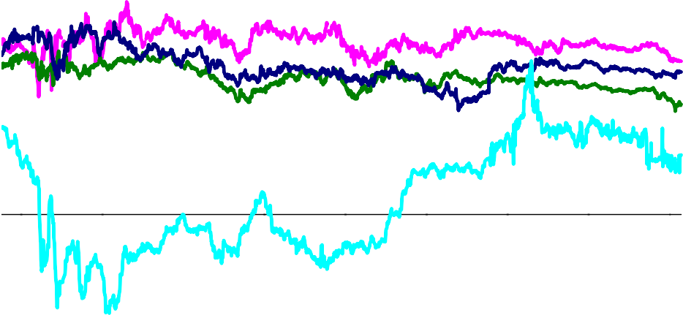

Per cent

4.0

3.0

2.0

1.0

0.0

-1.0

-2.0

2008 2009 2010 2011 2012 2013 2014

Source: Bloomberg and Bank calculations. Notes: The UK line is adjusted down by 1pp to take account of the RPI-CPI wedge. As there are very few index linked bonds for Japan, the 1 year forward inflation rate in 2018 is shown as a rough proxy.

**Chart 7:** Probability of a high-impact event in the UK financial system

Net percentage balances

Short term Medium term

40

30

20

10

0

-10

-20

-30

2013 H2

2013 H1

2012 H2

2012 H1

2011 H2

2011 H1

2010 H2

2010 H1

2009 H2

2009 H1

2008

High Very high Low Very low Net

2014 H2

2014 H1

2013 H2

2013 H1

2012 H2

2012 H1

2011 H2

2011 H1

2010 H2

2010 H1

2009 H2

2009 H1

2008

Sources: Bank of England Systemic Risk Survey and Bank calculations. Notes: Respondents were asked for the probability of a high- impact event in the UK financial system in the short and medium term. From the 2009 H2 survey onwards, short term was defined as 0-12 months and medium term as 1-3 years. The net percentage balance is calculated by weighting responses as follows: very high (1), high (0.5), medium (0), low (-0.5) and very low (-1). Bars show the contribution of each component to the net percentage balance.

**Chart 8:** The number of dissenting MPC members over time

Bank Rate decisions Asset Purchase decisions No. of members

5

4

3

2

1

Jun-97

Jun-00

Jun-03

Jun-06

Jun-09

0

Jun-12

Source: Bank calculations based on published data available at: <http://www.bankofengland.co.uk/monetarypolicy/pages/decisions.aspx>

**Chart 9:** Number of meetings where at least one MPC member has deviated from the majority

tings

Bank Rate decisions

Asset Purchase decisions

No. of mee

100

90

80

70

60

50

40

30

20

10

0

Internal members External members

Source: Bank calculations based on published data available at: <http://www.bankofengland.co.uk/monetarypolicy/pages/decisions.aspx>

**Chart 10:** CPI inflation projection from the November 2014 *Inflation Report*

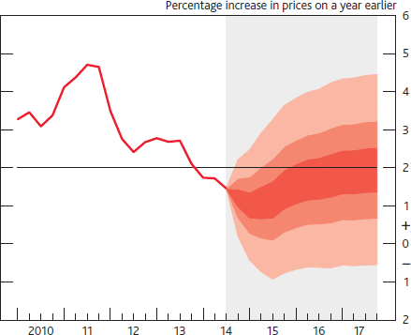

Source: Bank of England November 2014 *Inflation Report*. Notes: It has been conditioned on the assumption that the stock of purchased assets financed by the issuance of central bank reserves remains at £375 billion throughout the forecast period. If economic circumstances identical to today’s were to prevail on 100 occasions, the MPC’s best collective judgement is that inflation in any particular quarter would lie within the darkest central band on only 30 of those occasions. The fan chart is constructed so that outturns of inflation are also expected to lie within each pair of the lighter red areas on 30 occasions. In any particular quarter of the forecast period, inflation is therefore expected to lie somewhere within the fan on 90 out of 100 occasions. And on the remaining 10 out of 100 occasions inflation can fall anywhere outside the red area of the fan chart. Over the forecast period, this has been depicted by the light grey background. See the box on pages 48–49 of the May 2002 Inflation Report for a fuller description of the fan chart and what it represents.

**Chart 11:** The uncertainty parameter in the one year ahead inflation and GDP fan charts

2.0

Standard deviation

Inflation

GDP

1.8

1.6

1.4

1.2

1.0

0.8

0.6

0.4

0.2

0.0

1998Q1 2001Q1 2004Q1 2007Q1 2010Q1 2013Q1

Source: Bank calculations. Notes: The chart shows the standard deviation implicit in the one year ahead probability distribution published in the MPC Inflation Reports since 1998. See the box on pages 48–49 of the May 2002 Inflation Report for a fuller description of the fan chart.

**Chart 12:** Dispersion of inflation and GDP growth outturns since 2007Q3 across the quintiles of the one year ahead *Inflation Report* fan chart distributions

Percentages of outturns

70

Inflation

GDP growth

60

50

40

30

20

Lower

Higher

Lower

10

0

Higher

Source: Bank calculations. Notes: For further details on the methodology please see Hackworth *et al* (2013).

**Chart 13:** Estimate of the proportion of MPC minutes covering the topic of ‘banking’

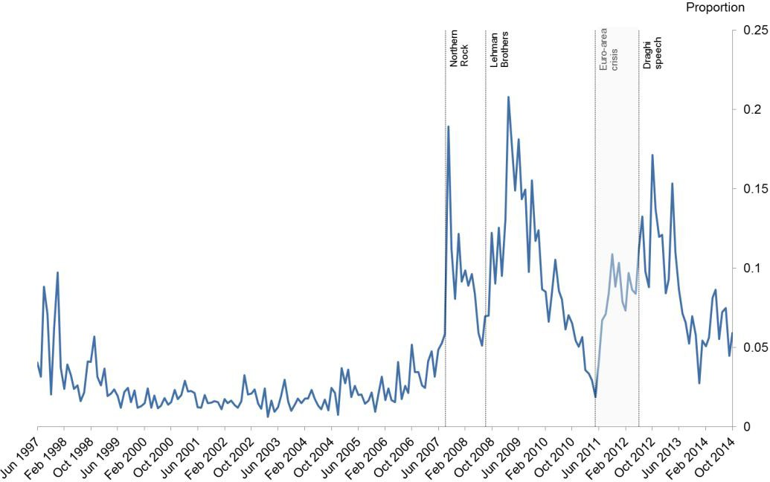

Source: Bank calculations. Notes: This chart shows the estimated allocation of each month’s MPC minutes to a topic which we label "banking". The words used most frequently in the topic are bank(s)/banking/banker(s), credit(s), financial/finance, market(s), asset(s), condition(s), money and lend(s)/lending/lender. The estimation of the topics, and the allocation of each set of minutes across all topics is completed using latent Dirichlet allocation as applied to FOMC transcripts in Hansen *et al* (2014). The lines correspond to: September 2007 when Northern Rock received a liquidity support facility from the Bank of England; September 2008 when Lehman Brothers filed for bankruptcy; June 2011 when speculation and uncertainty about the euro area sovereign debt crisis started escalating; June 2011 when ECB President Mario Draghi delivered his ‘whatever it takes’ speech.

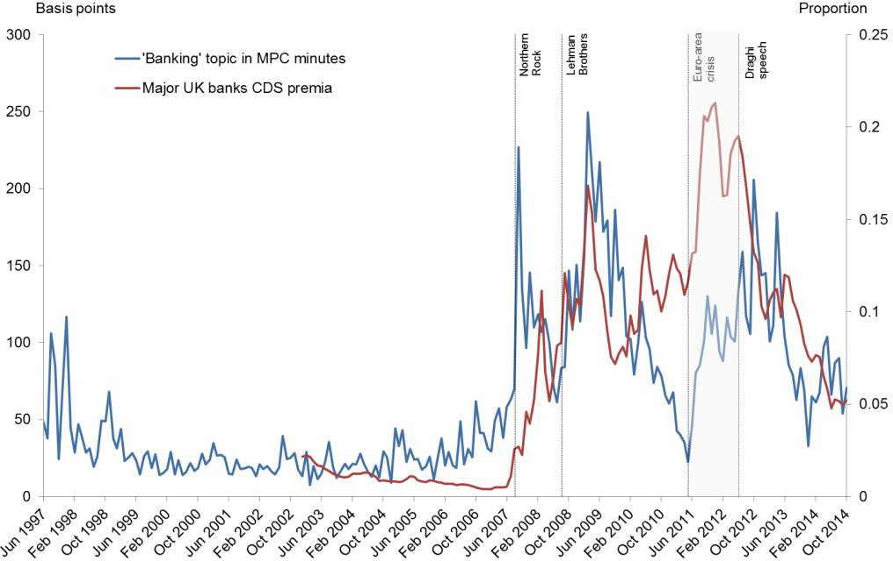**Chart 14:** Estimate of the proportion of MPC minutes covering the topic of ‘banking’ and major UK banks CDS premia

Source: Bank calculations and Bloomberg. Notes: The blue and vertical lines are the same as Chart 13. Major UK banks include: Standard Chartered, Santander UK, RBS, Barclays, LBG, HBOS, and HSBC but does not include Northern Rock.

**Chart 15:** One year ahead inflation and GDP forecast errors

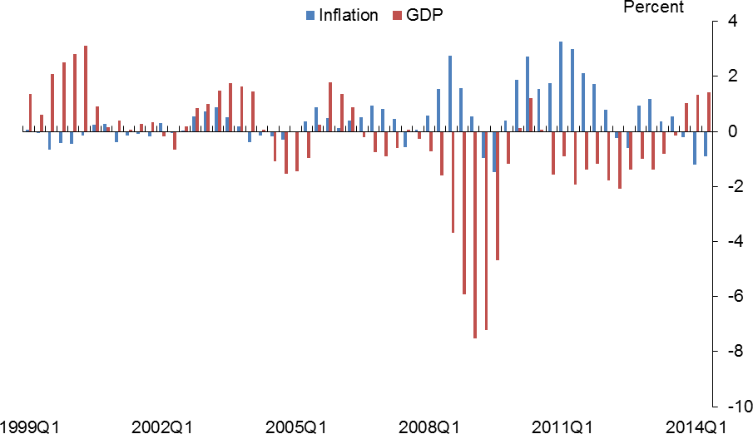

Source: Bank calculations.